

**User Manual**

**Part I**

Contents

A) LANDING PAGE 3

B) LOGIN 4

C) COMPANY PROFILE 5

1. Administration > Setting Up Your Company Profile 5

D) OPERATIONAL AND FINANCIAL MODULES 7

I) ACCOUNTS PAYABLE 7

1. Adding, Modifying, or Deleting a Vendor Group 7

2. Adding, Modifying, or Deleting a Vendor 10

3. Entering an Invoice 12

1. Open Accounts Payable > A/P Transactions 1. > Invoice Entry.Entering an Invoice 13

4. Entering and Applying a Payment 16

5. Adjusting a Posted Transaction 19

II) ACCOUNTS RECEIVABLE 22

1. Adding, Modifying, and Deleting Customer Groups 22

2. Adding and Modifying Customer Records 24

3. Invoicing a Customer 26

4. Processing a Cash Sale or Miscellaneous Receipt 30

5. Adding a Receipt to a Deposit Slip for Quick Deposit 34

6. Adding, Editing, or Deleting an Adjustment Batch 37

7. Printing the A/R Deposit Slips and Day –end Report 39

III) BANK SERVICES 41

1. Adding Bank Entries 41

2. Reconciling a Bank Account 43

3. Posting Bank Reconciliations 47

4. Printing the Bank Reconciliation Status Report 48

IV) GENERAL LEDGER 49

1. Adding a Journal Entry 49

2. Posting Transaction Batches (After adding journal entries) 53

# LANDING PAGE

The landing page is the repository of all the modules the platform.

It consists of all the modules of the platform:

* ERP
* Budget
* Fixed Assets
* Investment

And the links to access:

* The user manual
* The forms and
* The support

This can be accessed through: **{link}**

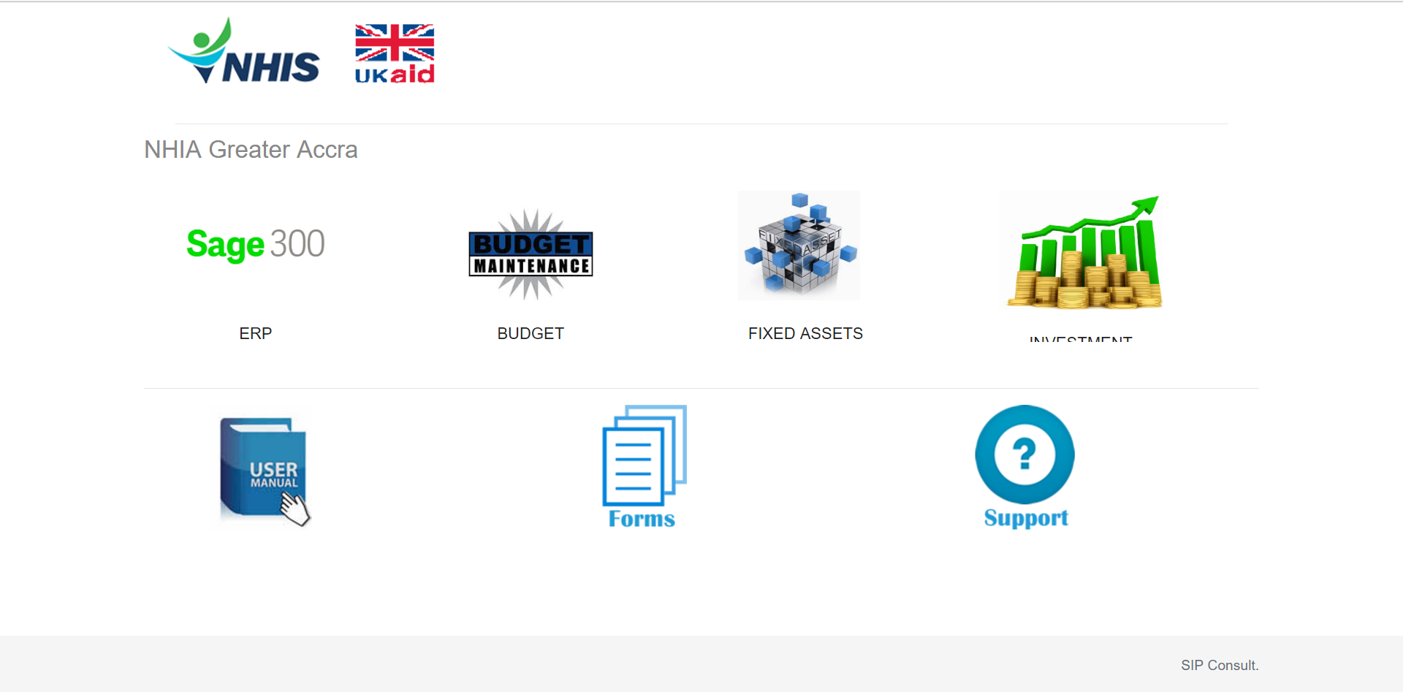

# LOGIN

To login in the SAGE ERP, you need username and password communicated to you by your regional office.

To login, go the SAGE ERP from the landing page:

* Enter username;
* Enter your password
* Choose your district and
* Click on **Sign In**

1

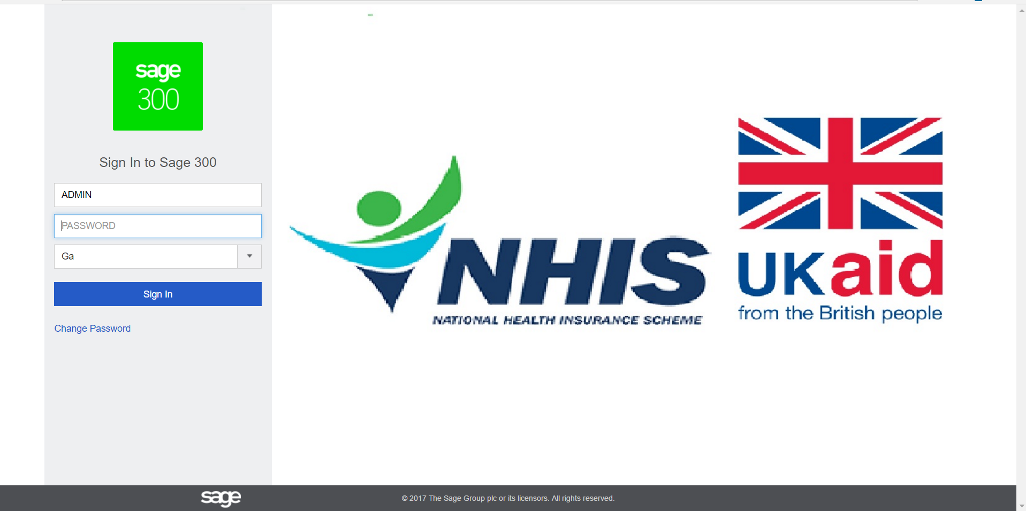

If your login are denied after 3 attempts, quickly contact the support on the landing page.

# COMPANY PROFILE

### Administration > Setting Up Your Company Profile

To Edit or Update Company`s Profile

You use the Company Profile screen to review and edit general information and settings for your company, including:

Address and contact information.

Functional currency.

Number of periods in the fiscal year.

Whether to display an error, a warning, or no message if users try to process transactions for locked fiscal periods or to inactive or non-existent General Ledger accounts.

Number of days before or after the session date that a transaction date can be entered without triggering a warning.

For more information about information and settings, see Company Profile Screen.

**To change information in your company profile:**

1. Open **More** > **Common Services** > **Company Profile**.

1

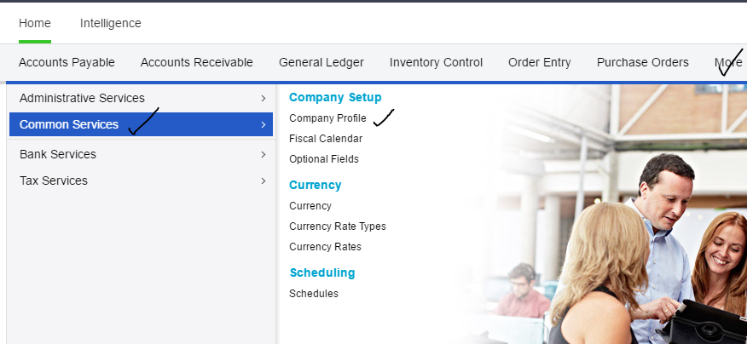

2

2. Edit your company profile.

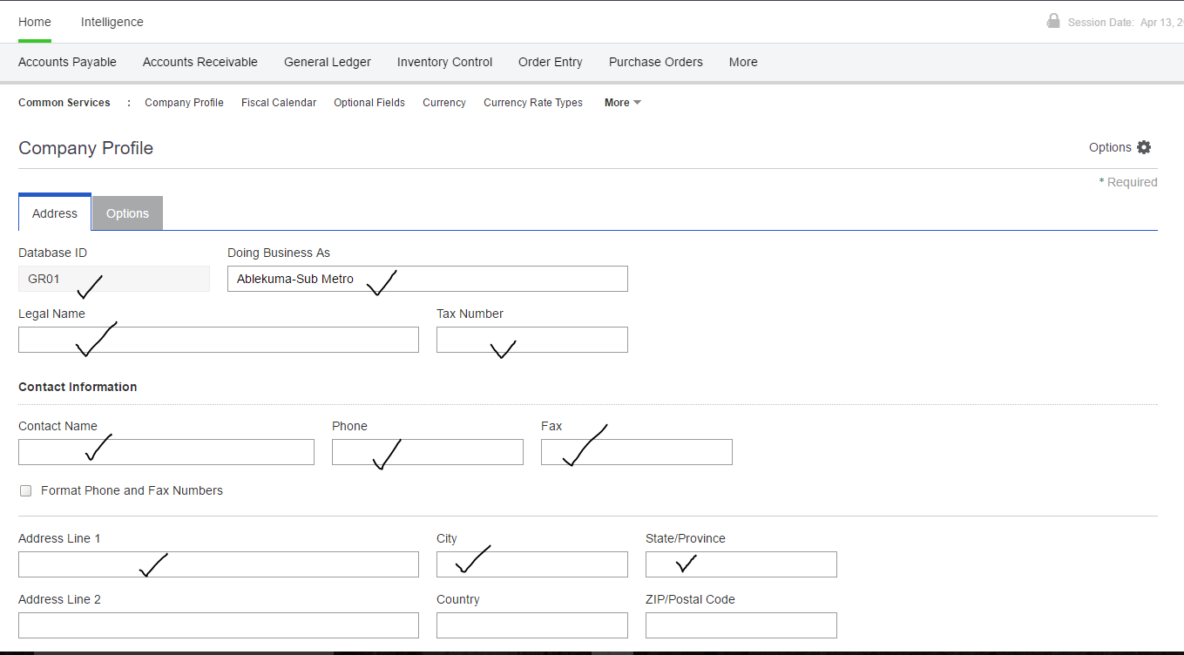

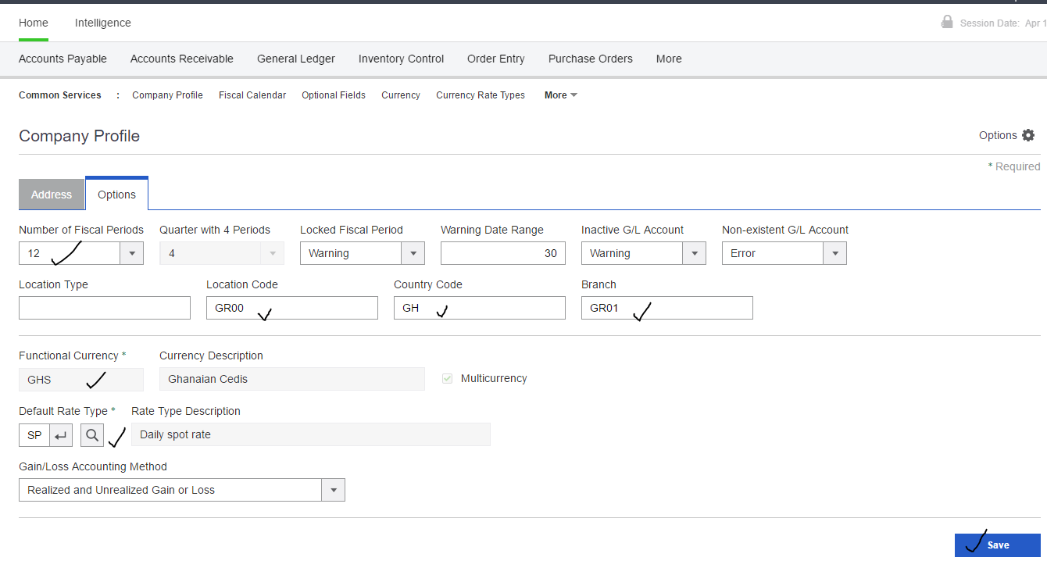

3

3. Click **Save**.

# OPERATIONAL AND FINANCIAL MODULES

## ACCOUNTS PAYABLE

The Module is made of:

### Adding, Modifying, or Deleting a Vendor Group

*You use the A/P Vendor Groups screen to add records for vendor groups to Accounts Payable. You must add at least one vendor group record before you can add vendor records.*

You can change the information in a vendor group record at any time, with some restrictions. [More...](javascript:void(0);)

**Note:**Most of the changes you make to a vendor group record have an effect only on new vendor records you create and add to the group, later.

**To add a vendor group record:**

1. Open **Accounts Payable** > **A/P Vendors** > **Vendor Groups**.

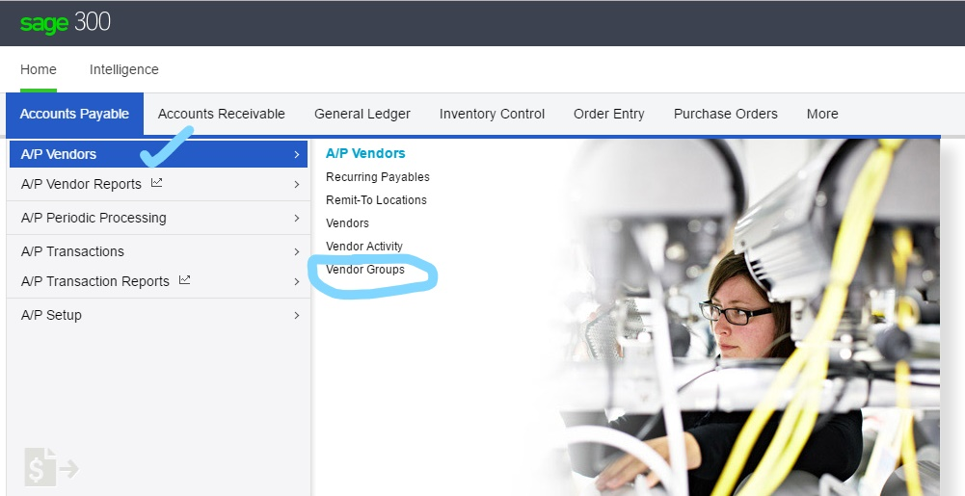

3

2

1

2. Click the **Create New** button.

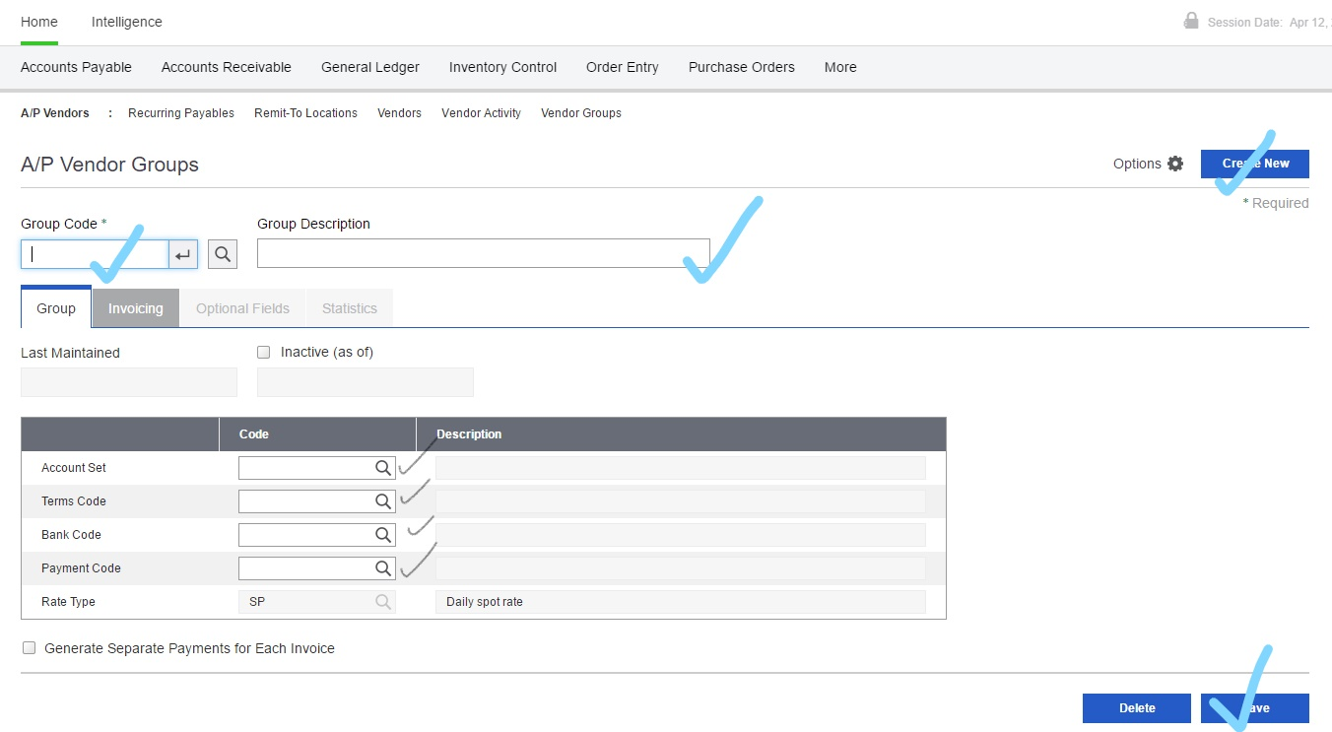

7

3

2

1

1. In the **Group Code** field, enter a code for the new vendor group.

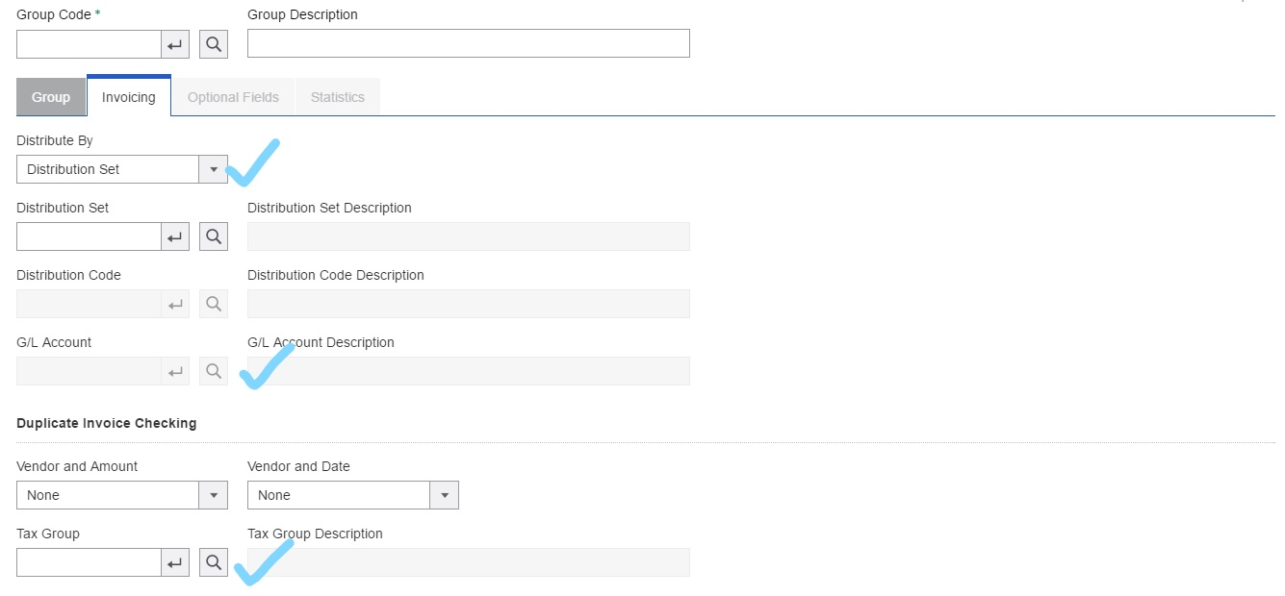

5

6

4

1. Complete the fields on the vendor group record.
2. Click **Add**.

**To edit or view an existing vendor group record:**

1. Open **Accounts Payable** > **A/P Vendors** > **Vendor Groups**.
2. In the **Group Code** field, specify the vendor group record you want to edit.
3. Make the changes you need in the record.

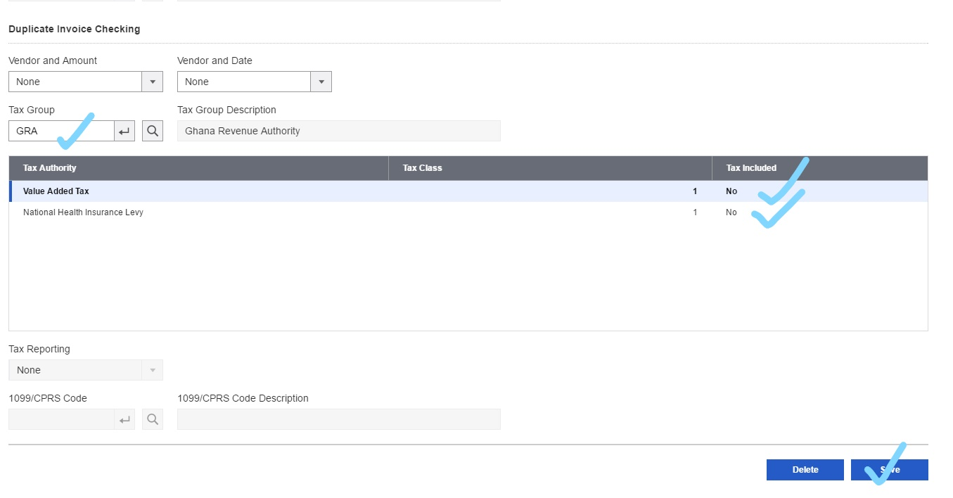

1. Click **Save**.

**To delete a vendor group record:**

1. Open **Accounts Payable** > **A/P Vendors** > **Vendor Groups**.
2. In the **Group Code** field, specify the vendor group record you want to delete.
3. Click **Delete**.
4. If a message appears asking you to confirm that you want to delete the record, click **Yes**.

### Adding, Modifying, or Deleting a Vendor

You use the A/P Vendors screen to add records for your vendors to Accounts Payable. You must add vendor records before you can enter and process transactions in Accounts Payable.

You can change the information in a vendor record at any time, with some restrictions. [More...](javascript:void(0);)

We recommend that you do not change the vendor group or account set assigned to a vendor record to which you have posted transactions. [More...](javascript:void(0);)

[[](javascript:void(0);)Before you start](javascript:void(0);)

**To add a vendor record:**

1. Open **Accounts Payable** > **A/P Vendors** > **Vendors**.

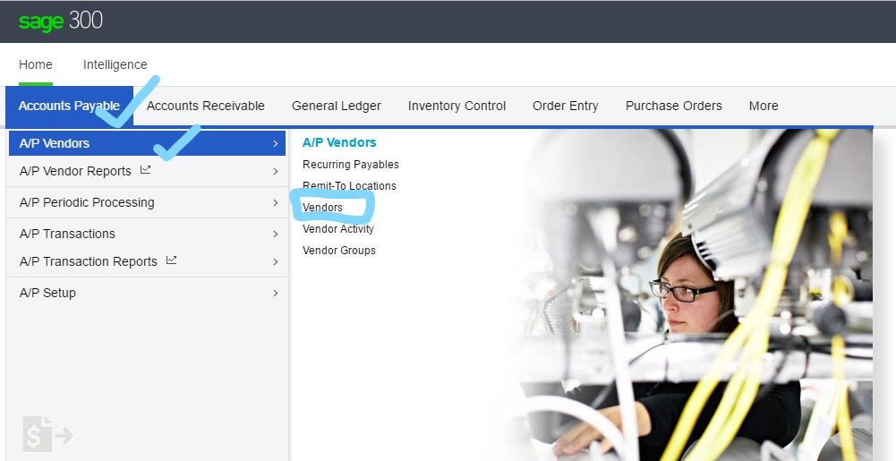

3

2

1

1. Click the **Create New** button.

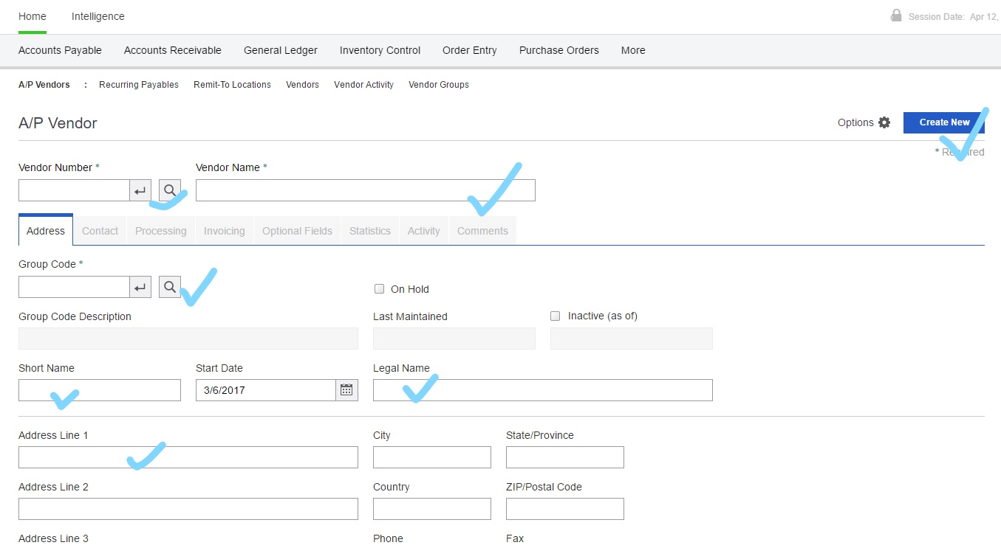

4

3

2

1

1. In the **Vendor Number** field, enter the code for the new vendor.
2. Complete the fields on the vendor record.

1

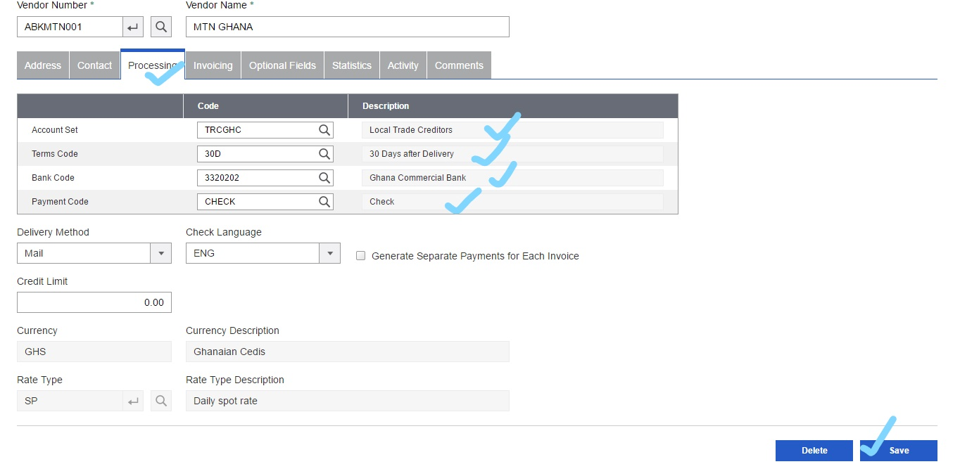

2

1. Click **Save**.

**To edit or view an existing vendor record:**

1. Open **Accounts Payable** > **A/P Vendors** > **Vendors**.
2. In the **Vendor Number** field, specify the vendor record you want to edit.
3. Make the changes you need in the record.

**Note:**

If you change the vendor group:

* + Defaults for the new vendor group are applied to the vendor record.
  + Statistical comparisons between fiscal periods or between vendor groups are invalidated (unless you update the vendor group statistics).

1. Click **Save**.

**To delete a vendor record:**

1. Open **Accounts Payable** > **A/P Vendors** > **Vendors**.
2. In the **Vendor Number** field, specify the vendor record you want to delete.
3. Click **Delete**.
4. If a message appears asking you to confirm that you want to delete the record, click **Yes**.

### Entering an Invoice

You use the A/P Invoice Entry screen to add invoices and interest invoices to invoice batches.

For an overview of invoice entry, see About Processing Invoices, Credit Notes, Debit Notes, and Interest.

For an overview of tax calculation on invoices, see About Calculating Tax.

Before you start

Make sure you have complete information for each document you want to enter, including the vendor number, document number, date, and purchase order number, if any.

Determine the distribution code or general ledger account number, item number, unit of measure, quantity, and price for each detail.

In multicurrency ledgers:

Find out the rate type, rate date, and exchange rate to use for each invoice, credit note, debit note, prepayment, and interest charge.

Update currency information and exchange rates in the Currency screens, if necessary.

If retainage applies to the document, find out the retainage percentage or retainage amount, retention period, retainage due date, retainage terms, and whether to use the exchange rate from the original document or the current exchange rate when you process the outstanding retainage.

### To add an invoice:

Open Accounts Payable > A/P Transactions 1. > Invoice Entry.Entering an Invoice

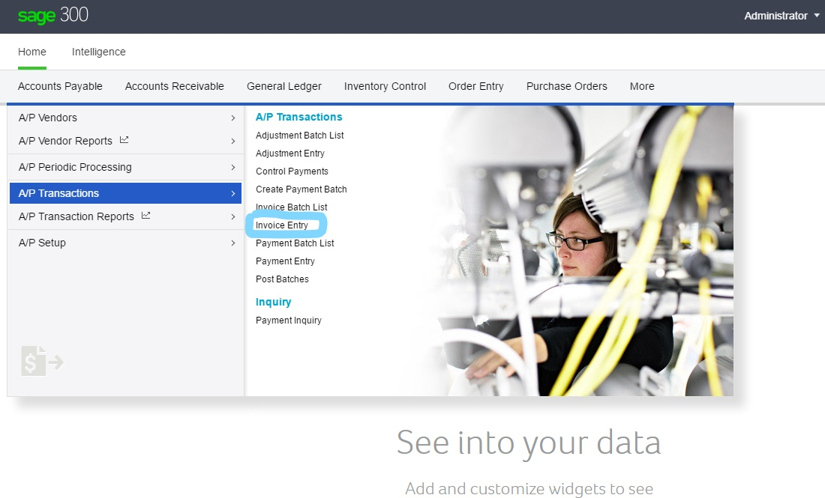

3

2

1

1. Select an existing batch using the Batch Number field, or create a new batch. More...

To create a new batch:

a. Click the **Create New** button beside the **Batch Number** field.

b. In the **Batch Description** field, type a description for the batch.

c. In the **Batch Date** field, enter a date for the new batch, or accept the session date.

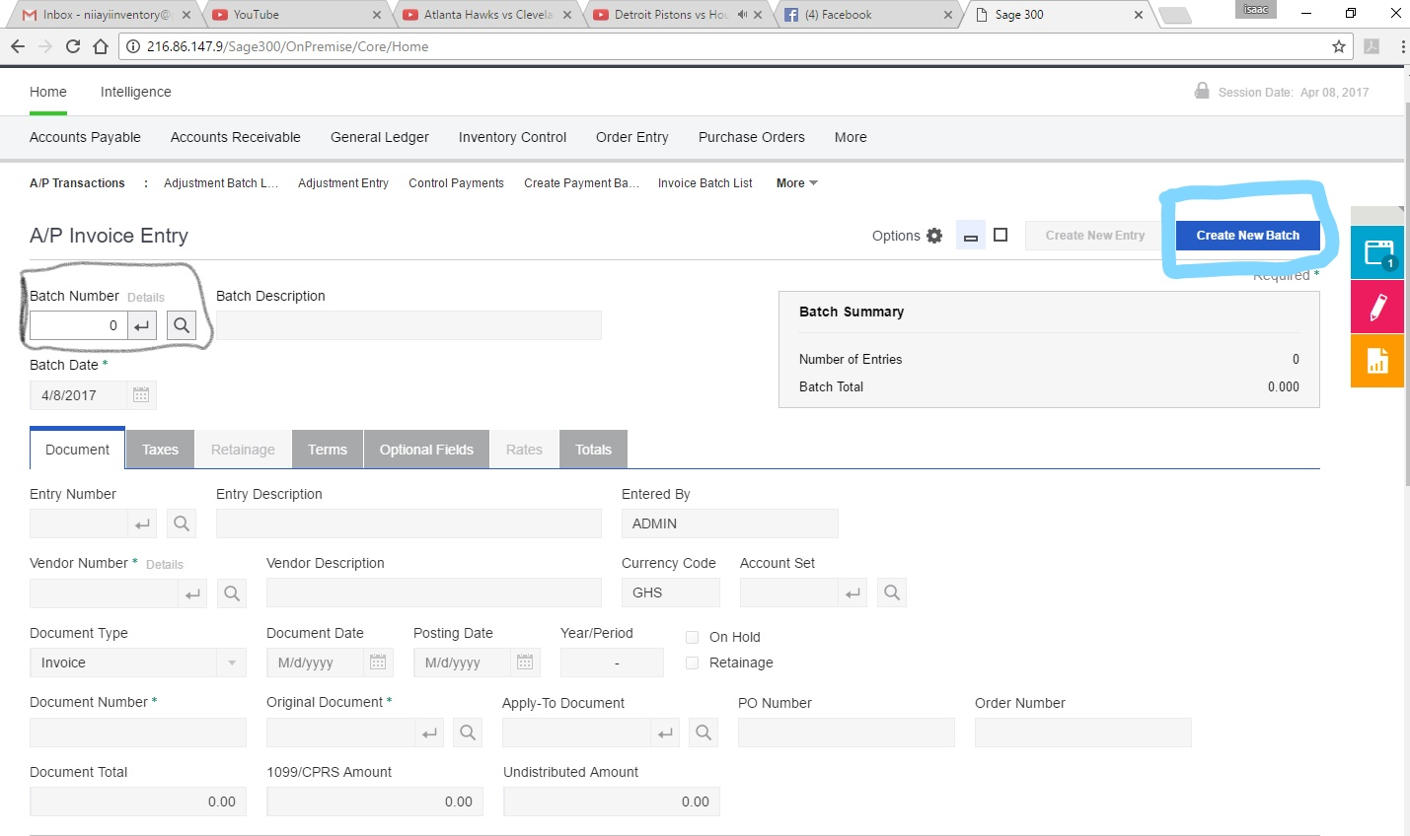

2

1

3. Click the **Create New Entry** button to start a new document, and then enter a description for the entry.

Enter header information for the document on the Document tab. More...

You enter the following information for the header:

**Vendor Number.** Specify the vendor who issued the invoice, debit note, or credit note.

Entering an Invoice http://help.sage300.com/en-US/2017/web/Subsystems/AP/Content/Trans...

Enter distribution details. More...

Enter the following distribution information:

**Distribution Set.** Accept or change a displayed code, as needed, or specify a code if none appears, and you want to use a distribution set.

**Distribution Amount.** Type the total amount to be distributed in the details created by the distribution set.

NB: This total does not have to be the full amount you have to distribute. For example, after creating distribution details from a distribution set, you may need to add distribution lines for general ledger accounts that are not included in the distribution set

Check to be sure you have distributed all document amounts before you calculate tax for the document.

After distributing taxes, you should have distributed all document amounts, and the Undistributed Amount field should show zeros. More...

If the Undistributed Amount field does not show zeros, you have distributed either more or less than the total amount to distribute.

**Examples:**

If the Undistributed Amount contains a positive number, you have not distributed the total invoice.

If you used Calculate or Distribute as the tax entry method and tax is included, you must also distribute the tax amount.

If the Undistributed Amount is a negative amount (with a minus sign or in parentheses), check to see whether you accidentally distributed the taxes.

**Tip:** Click the Totals tab to see the document summary information, so you can find out where the mistake occurred.

6. To check or change taxes for the document, click the Taxes tab.

Click the **Distribute Taxes** button to allocate tax to each of the distributions in the list. The amounts are also displayed in the Allocated Tax column of the Document detail-entry table.

You can edit the tax amount that was allocated to each distribution detail if you select Enter as the tax entry method on the Taxes tab.

For more information, see Editing Taxes on an Invoice, Debit Note, or Credit Note.

7. Use the Retainage tab to specify terms for the retainage document on an invoice from which retainage will be deducted.

**Note:** In a multicurrency ledger, you also specify which rate to use when you process the retainage.

8. Use the Terms tab to enter Payment terms for the invoice

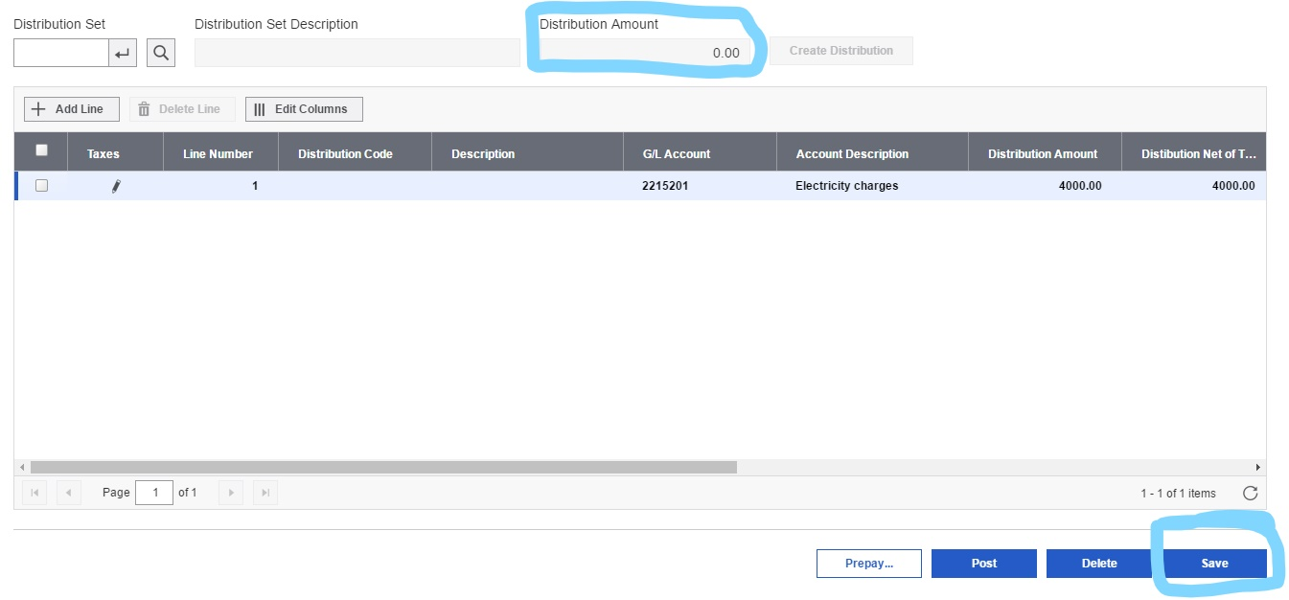

4

3

Click **Save** to add this document 12.to the batch. After adding an invoice, debit note, or credit note

Print the invoice.

Print the Batch Listing report. Make corrections, if needed, and then reprint the listing for each corrected batch.

**Note:** You must print batch listings before posting batches, if the Force Listing Of All Batches option is selected on the A/P Options screen. File the printed reports for your audit trail.

### Entering and Applying a Payment

You use the A/P Payment Entry screen to enter and apply vendor payments.

You can also use the A/P Payment Entry screen to print a single check for a vendors when you enter a payment, but if you want to enter and print checks for a large number of vendors, use the A/P Create Payment Batch screen.

**To add a vendor payment:**

1 .Open Accounts Payable, Scroll to Transactions and Click on Payment Entry

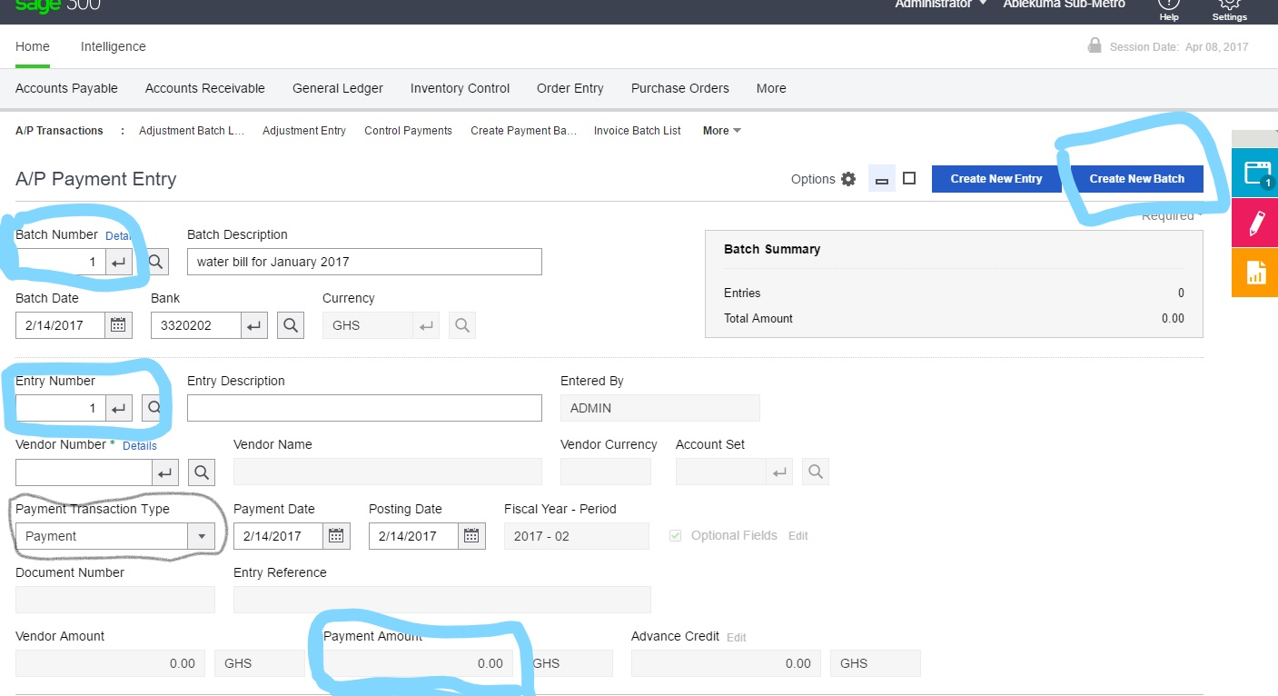

5

4

3

2

1

2 .Select an existing Batch or Click Create New (to add a new batch)

3 .Enter Description Details

4 .Select Payment type (Payment, Apply to Document, Prepayment etc.)

5 .Choose Vendor (Using the finder)

6 .Enter Document Number (If Any) or Search Using the Finder

7 .Enter Discount Amount (if any) and change Rate (if payment is in a different currency)



7

6

8 .Click Save

### Adjusting a Posted Transaction

If you need to change the amount for a posted transaction, you do so by entering an adjustment. You can also make changes to an existing adjustment, and then save your changes.

**To add an adjustment:**

1. Open **Accounts Payable** > **A/P Transactions** > **Adjustment Entry**.

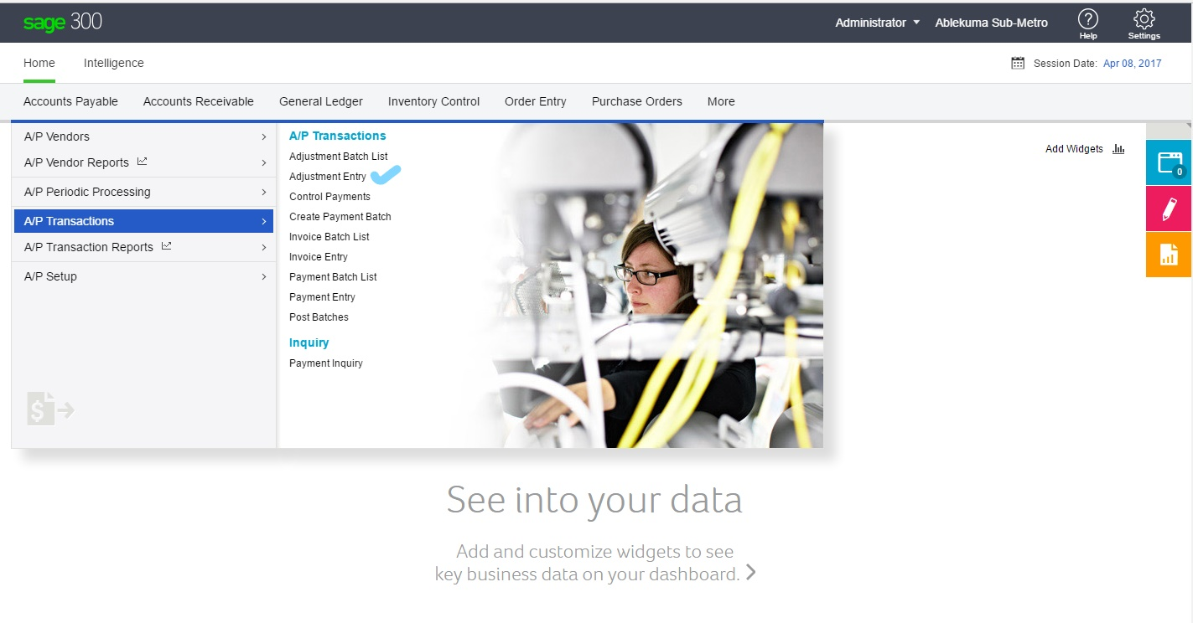

3

2

1

1. Select or create the adjustment batch to use.

4

1. To assign the entry number, click the **Create New Entry** button.

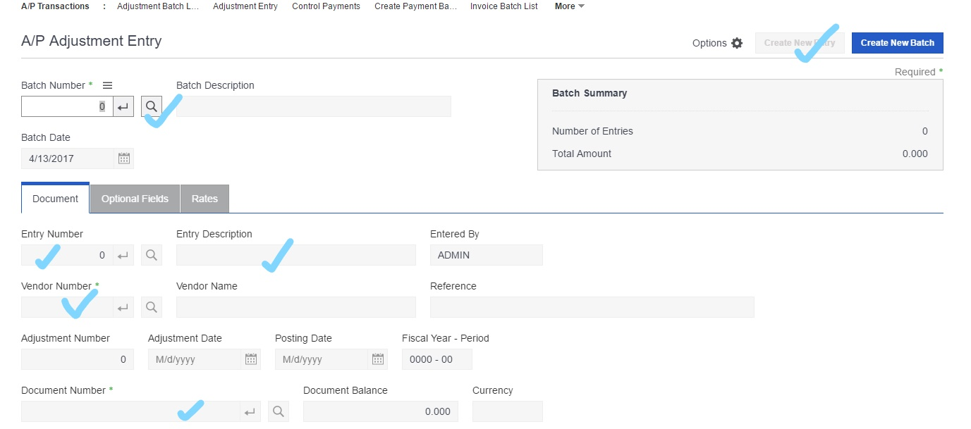

1. Enter an optional description for the entry, then enter the adjustment date, the posting date, the vendor number, an optional reference and reference description, the document number to adjust, and the payment number (if the adjusted document includes a payment schedule).
2. Select a detail for adjustment.
3. Include for each detail:
   * The distribution code or the general ledger account number.
   * The amount. (Enter a positive amount to reduce the balance of an invoice or debit note, or a negative amount to increase the balance of these documents.)
4. If you use retainage accounting, adjust retainage as necessary. For more information, see [About Processing Retainage in Accounts Payable](http://help.sage300.com/en-US/2017/web/Subsystems/AP/Content/PeriodicProcessing/CreatingRetainageBatches/AboutUsingRetainageAccountingIn_AP.htm).
5. Click **Save**.

5

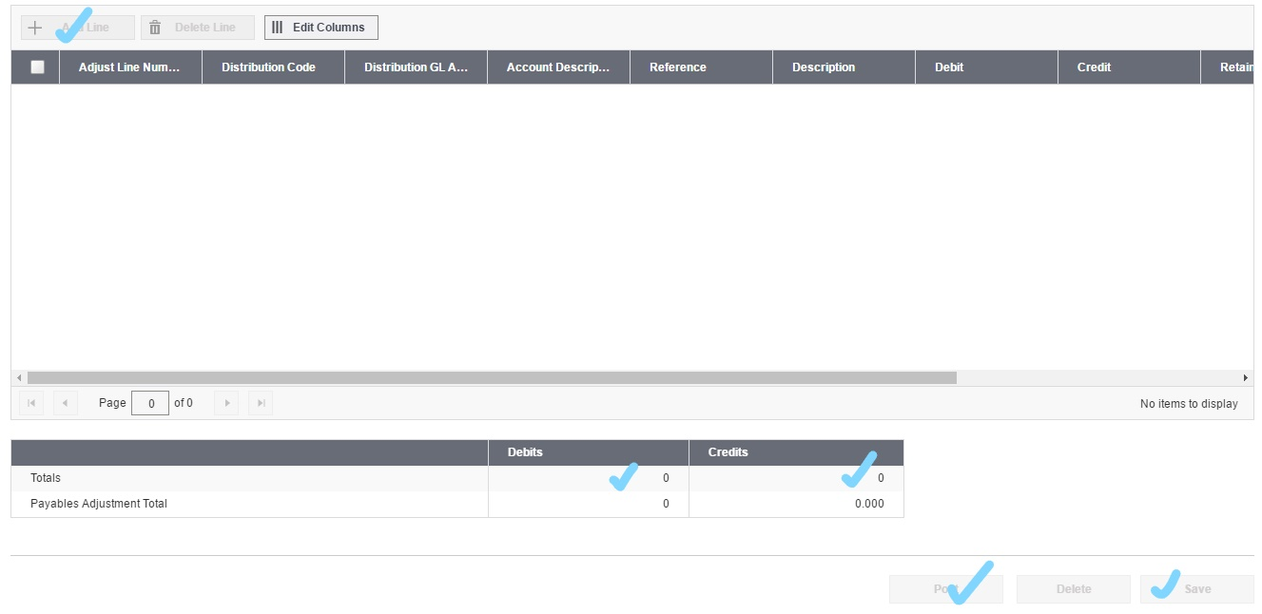

8

7

6

## ACCOUNTS RECEIVABLE

### Adding, Modifying, and Deleting Customer Groups

**Learn more**

You must add at least one customer group before you can add customer records or national accounts.

**Note:**Most changes you make to an existing customer group record affect only new customer and national account records created and added to the group after you save your changes. For more information, see [About Customer Groups](http://help.sage300.com/en-US/2017/web/Subsystems/AR/Content/Customers/CustomerGroups/AboutCustomerGroups.htm).

[[](javascript:void(0);)Before you start](javascript:void(0);)

**To add a customer group:**

1. Open **Accounts Receivable** > **A/R Customers** > **Customer Groups**.

1

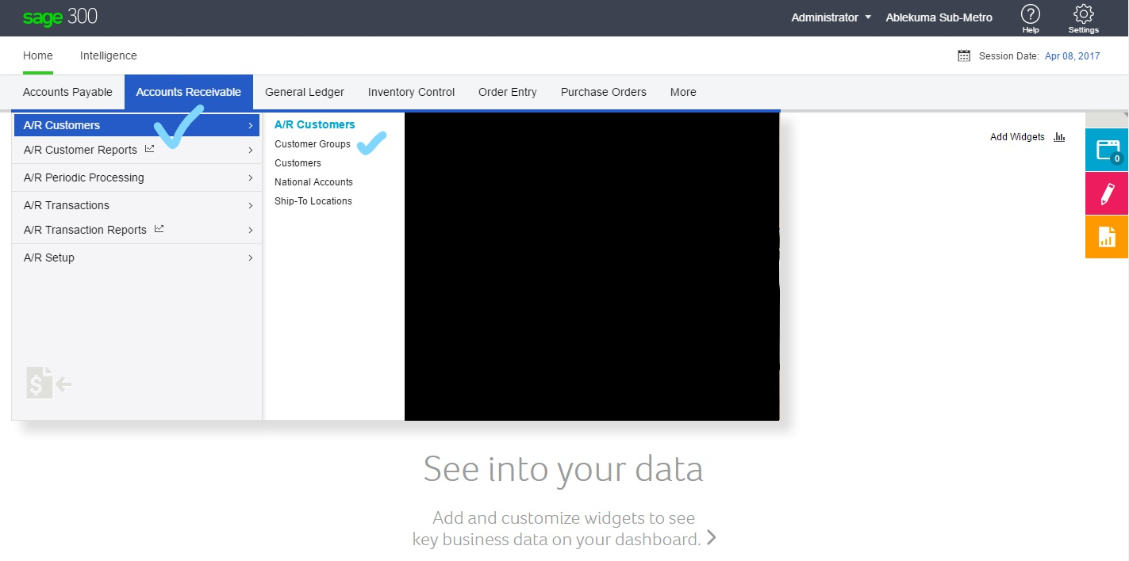

3

2

1. Click **Create New**.

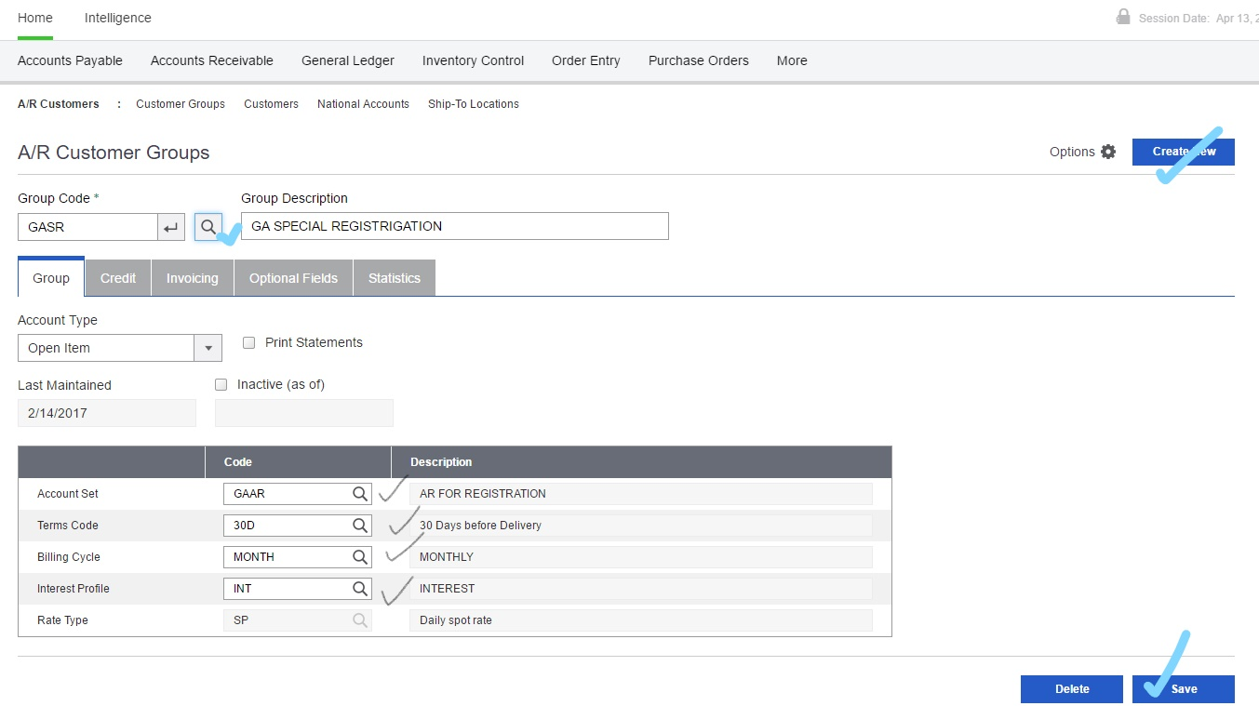

4

3

2

1

1. In the **Group Code** field, type the code for the new customer group, and then press the **Tab** key.
2. Fill in the fields on the Customer Groups screen.
3. Click **Add** to add the new group.
4. To add another record, repeat steps 2 through 5.

**To edit a customer group record:**

1. Open **Accounts Receivable** > **A/R Customers** > **Customer Groups**.
2. In the **Group Code** field, specify the code for the customer group you want to edit.
3. Make the changes you need in the record.
4. When finished, click **Save** to record your changes.

**To delete a customer group record:**

1. Open **Accounts Receivable** > **A/R Customers** > **Customer Groups**.
2. In the **Group Code** field, specify the code for the customer group you want to delete.
3. Click the **Delete** button.
4. If a message appears asking you to confirm the deletion, click **Yes**.

### Adding and Modifying Customer Records

**To add a new customer:**

1. Open **Accounts Receivable** > **A/R Customers** > **Customers**.

1

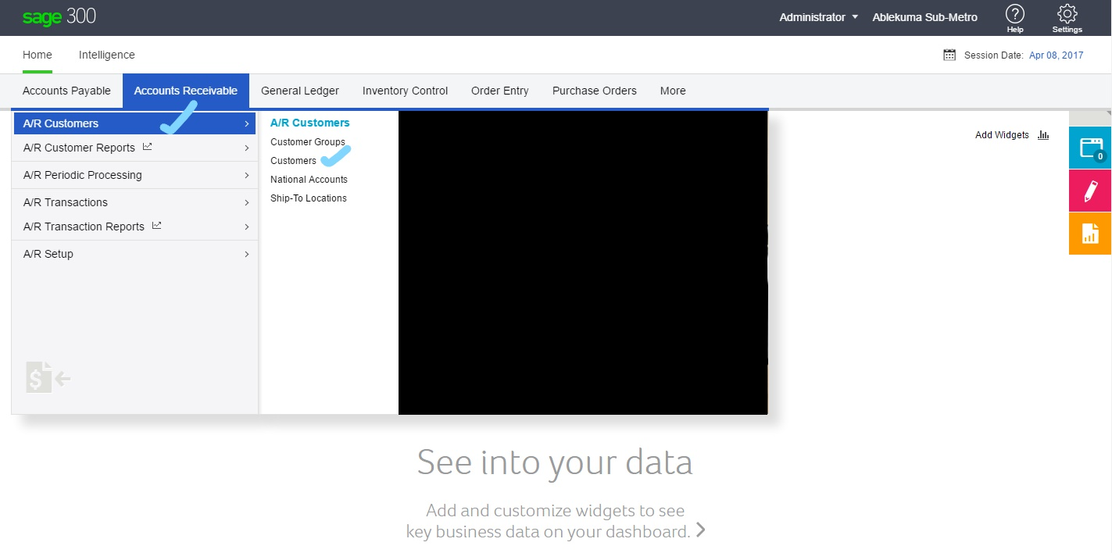

3

2

1. Click **Create New**.

4

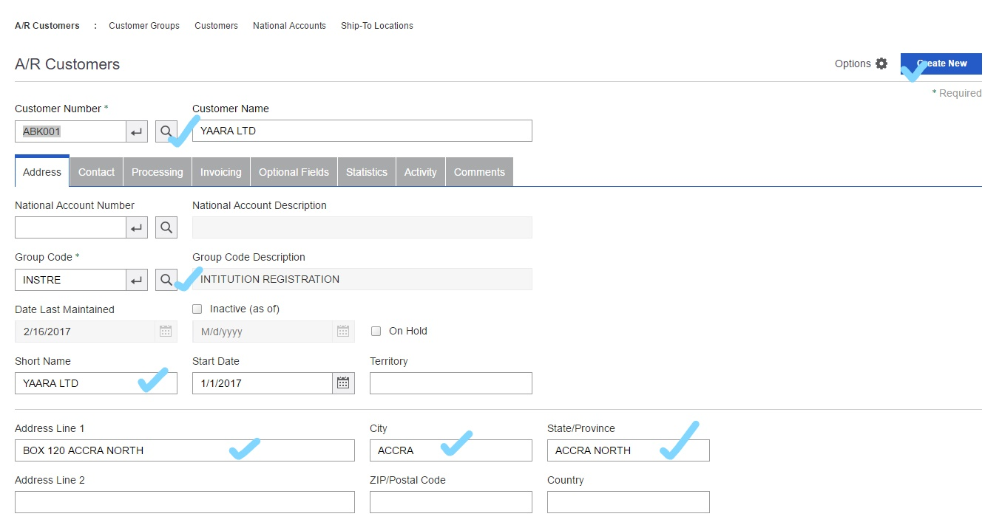

6

5

1. In the **Customer Number** field, enter the code for the new customer.
2. Complete the fields on the customer record.
3. Click **Add** to add the new customer.
4. If you want to add another record, repeat steps 2 through 5.

**To edit or view an existing customer record:**

1. Open **Accounts Receivable** > **A/R Customers** > **Customers**.
2. In the **Customer Number** field, select the code for the customer record you want to edit.
3. Make the changes you need in the record.
4. When finished, click **Save** to record your changes.

**To delete a customer record:**

1. Open **Accounts Receivable** > **A/R Customers** > **Customers**.
2. In the **Customer Number** field, select the code for the customer record you want to delete.
3. Click the **Delete** button.
4. If a message appears asking you to confirm the deletion, click **Yes**.

### Invoicing a Customer

**To add an invoice:**

1. Open **Accounts Receivable** > **A/R Transactions** > **Invoice Entry**.

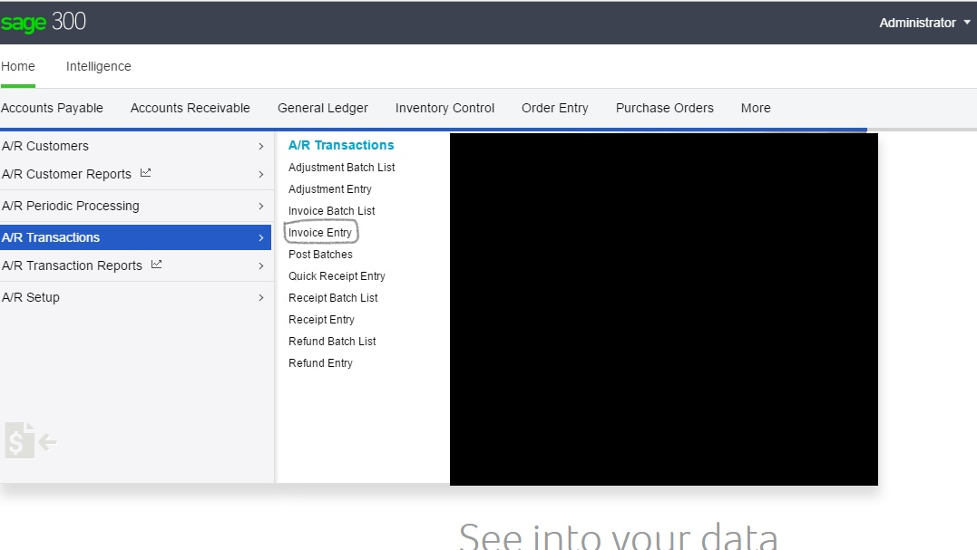

3

2

1

1. Use the **Batch Number** field to specify an existing batch, or create a new batch as follows:
   1. Click the **Create New Batch** button.

Accounts Receivable assigns a new batch number.

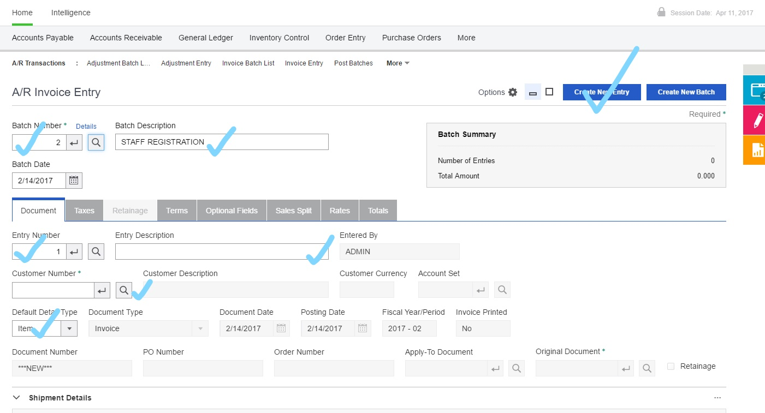

8

7

6

5

* 1. In the **Batch Description** field, type a description for the batch.
  2. Accept the session date in the **Batch Date** field, or type over the date if you want to change it.
  3. To view or change the default detail type for the batch:
     1. Click the **Edit** link to open the Batch Information screen.
     2. In the **Default Detail Type** field, select **Item** or **Summary**.
     3. Click **Close**.

1. Enter header information for the document on the Document tab.
2. On the Document tab, in the detail table, add summary details or item details
3. To check or change the taxes for a detail, click the **Detail Tax** button.
4. To check or edit invoice taxes, click the Taxes tab.
5. If this is an invoice from which retainage will be deducted, use the **Retainage** tab to specify terms for the retainage document.

**Note:**In a multicurrency ledger, you also specify which rate to use when you process the retainage.

1. To use different payment terms from those in the customer record, or to edit the payment schedule, click the **Terms** tab.
2. If you use invoice optional fields, click the **Optional Fields** tab to view or edit the optional fields assigned to this invoice.
3. To allocate sales to salespersons, or to revise existing information, click the **Sales Split** tab.

For information about allocating sales, see [Allocating a Sale to Salespersons](http://help.sage300.com/en-US/2017/web/Subsystems/AR/Content/Transactions/Invoices/AllocatingSaleToSalespersons.htm).

1. If the document does not use the functional currency and you need to change exchange rates, use the **Rates** tab to adjust them.

For more information, see [Editing Exchange Rate Information on an Invoice](http://help.sage300.com/en-US/2017/web/Subsystems/AR/Content/Transactions/Invoices/Editing/EditingExchangeRateInformationOnInvoice.htm).

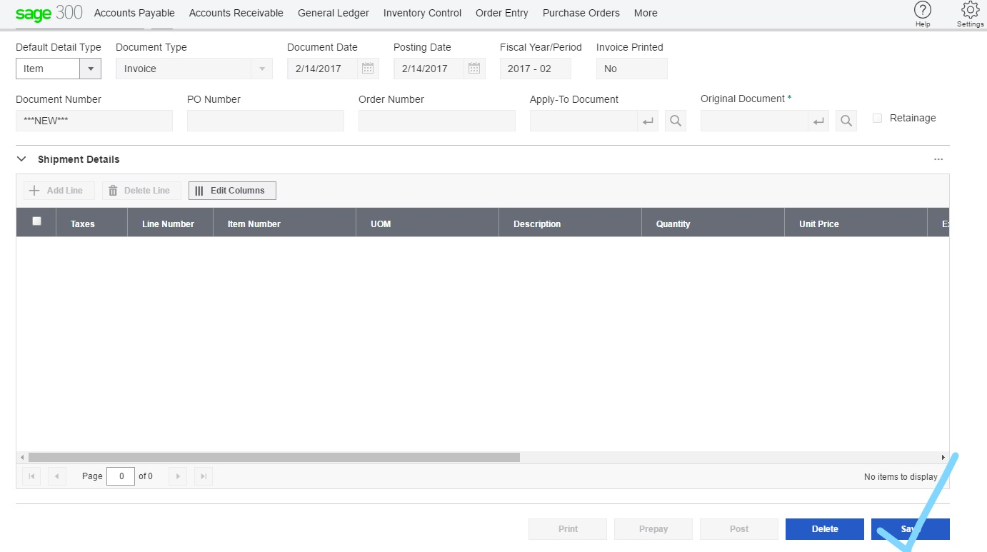

6

1. Click **Save** to add this document to the batch.

If you use credit checks for the customer, Accounts Receivable warns you if the customer has exceeded their credit limit or has transactions that have been outstanding for too long. (Close the A/R Credit Check screen if you receive a warning.) You can edit the transaction, or ignore the warning and save the entry.

1. If you need to enter a prepayment for an invoice, click **Prepay** to add it now.

**Note:**If you use Payment Processing, you can also use the Prepayments screen to process a credit card prepayment.

For more information about prepayments, see [Entering a Prepayment with an Invoice](http://help.sage300.com/en-US/2017/web/Subsystems/AR/Content/Transactions/Invoices/Prepayments/EnteringPrepaymentWithInvoice.htm).

1. Click **Save**

### Processing a Cash Sale or Miscellaneous Receipt

You add a miscellaneous receipt when you make a cash sale to a regular customer or when you receive a one-time payment from others.

If the payment is from a regular customer, Accounts Receivable generates a paid invoice for the sale when you post the receipt.

If you are entering a receipt for a one-time customer, for whom you do not create a customer record, Accounts

Receivable does not create an invoice when you post the receipt.

**To add a cash invoice or miscellaneous receipt:**

1. .Open **Accounts Receivable** > **A/R Transactions** > **Receipt Entry**.

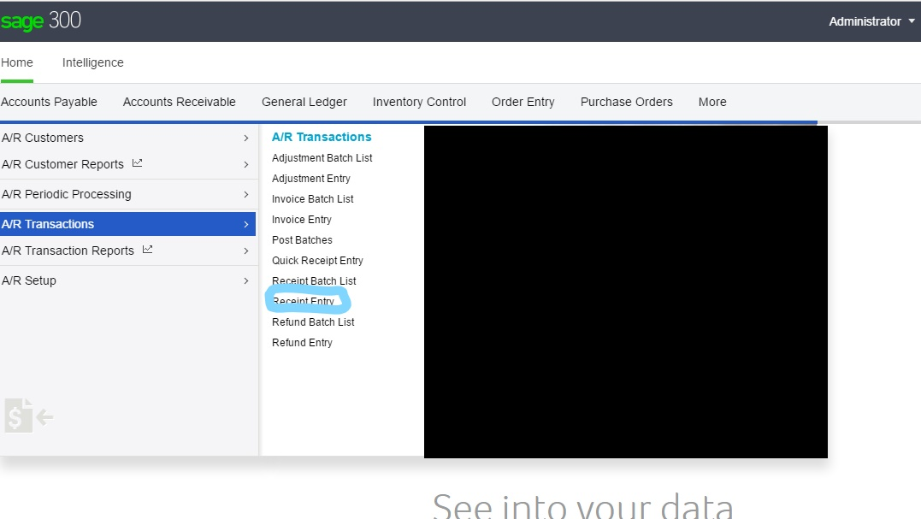

1

3

2

**Note:** You can use the A/R Quick Receipt Entry screen to add a miscellaneous receipt to a deposit slip, but you must use the A/R Receipt Entry screen to distribute the receipt to general ledger accounts.

1. .Select an existing batch or create a new one. More...

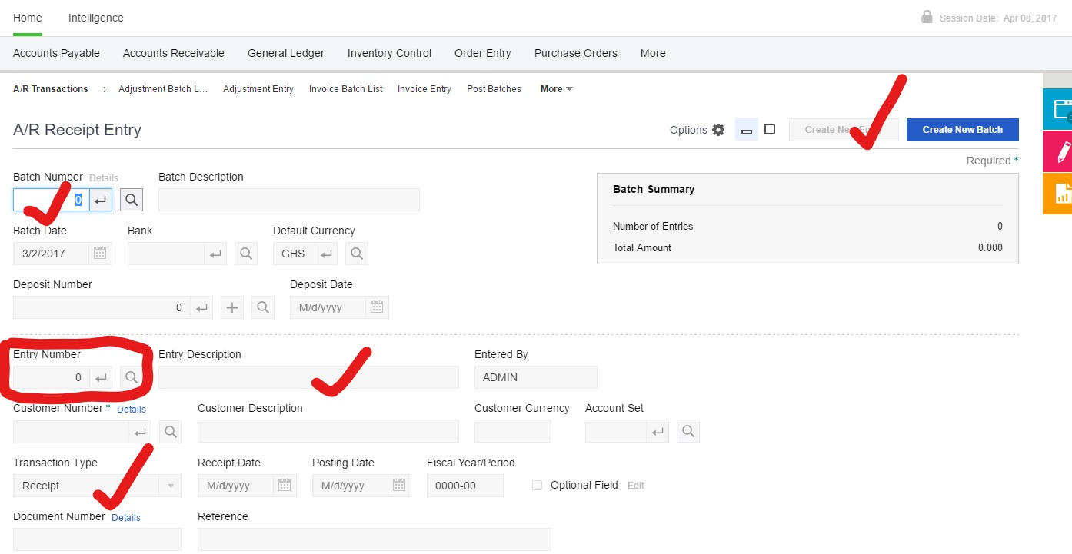

8

7

6

5

4

**Select an existing batch.** Use the Finder beside the **Batch Number** field to select the batch you want to work with.

**Create a new batch.** Click the **Create New Batch** button, and then enter the batch date, bank code, default currency (in a multicurrency ledger), and deposit number.

3 .Create a new miscellaneous receipt for the customer. More...

If you are using the A/R Receipt Entry screen:

a. Click the **Create** a. **New Entry** button.

b. In the **Transaction Type** field, select **Miscellaneous Receipt**.

c. If the receipt is from an existing customer, specify the customer in the **Customer Number** field.

If you are using the A/R Quick Receipt Entry screen:

Select the miscellaneous receipt from the list, or add a new line and select **Miscellaneous Receipt** in the Receipt Transaction Type column.

If the receipt is from an existing customer, specify the customer number for the detail in the **Customer Number** column.

Enter general information for the receipt entry, and then click **Open** to open the A/R Receipt Entry screen.

4. Enter general information for the receipt entry. More...

5. Enter distribution details for the receipt. More...

6. If you have a multicurrency ledger and you want to specify the exchange rate for the miscellaneous receipt:

a. Click **Rates**.

b. On the A/R Rate Override screen that appears, change the rate date and exchange rate, as necessary.

c. Click **OK**.

7. To check or change the taxes calculated for the document (including the tax reporting amount), or to change the tax group for the document, click the **Taxes** button.

8. To check the taxes calculated for a distribution detail, or to enter them manually if tax is not calculated automatically for the receipt, select the detail, and then click **Detail Tax**.

9. Click **Save**.

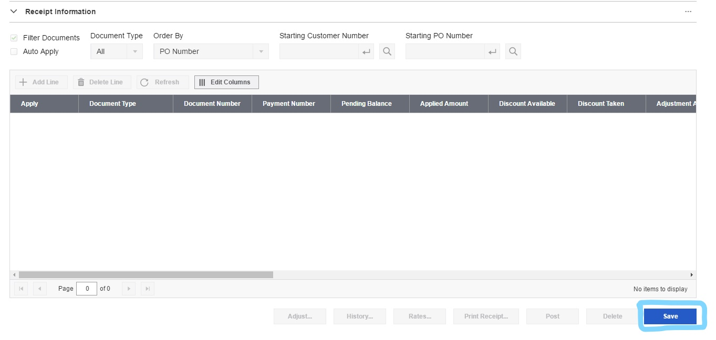

9

10. If you use Payment Processing and selected a payment code that uses the payment type SPS Credit Card, click the **Charge** or **Quick Charge** button to process a credit card payment for the receipt.

NB. After distributing the receipt:

Post the receipt batch when you have finished adding receipt entries. For more information, see

Posting a Receipt Batch.

Accounts Receivable creates a paid invoice when you post a miscellaneous receipt for an Accounts

Receivable customer.

### Adding a Receipt to a Deposit Slip for Quick Deposit

On the A/R Quick Receipt Entry screen, you can enter sufficient information for cash, check, and other receipts so that you can print a deposit slip and take the money to the bank in a timely manner.

Before you start

**To add a receipt to a deposit slip:**

Open **Accounts Receivable** > **A/R Transactions** > **Quick** 1. **Receipt Entry**.

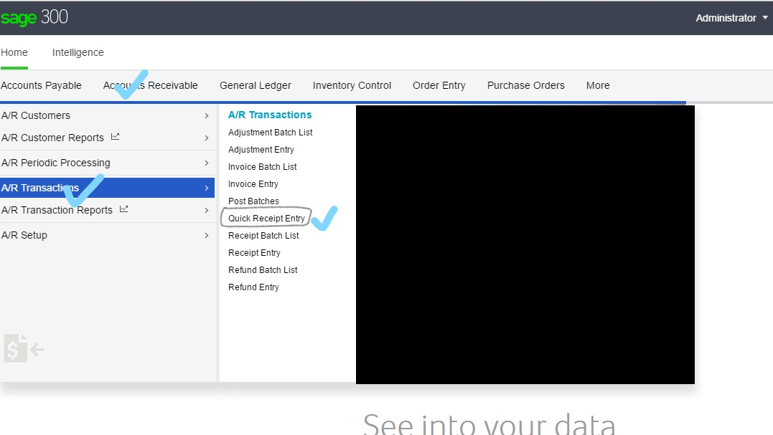

3

2

1

2. Do one of the following:

**Select an existing batch.** Use the Finder beside the **Batch Number** field to display the batch you want to use.

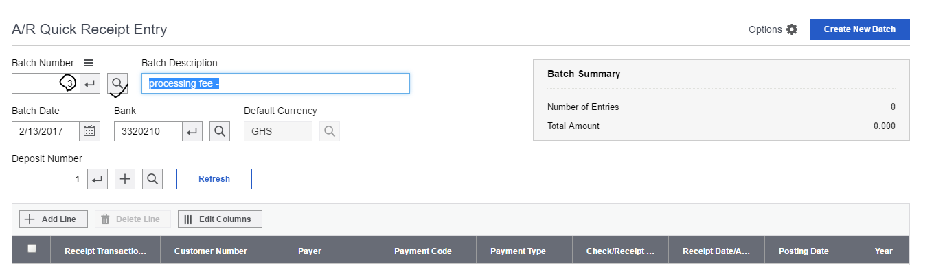

5

4

1

**Create a new batch.** Click **Create New**, then enter batch information.

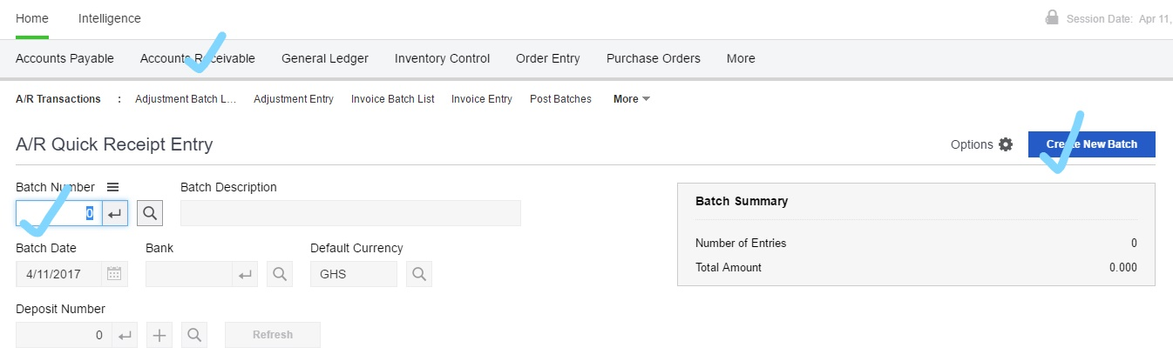

3

2

3. Click **Add Line**.

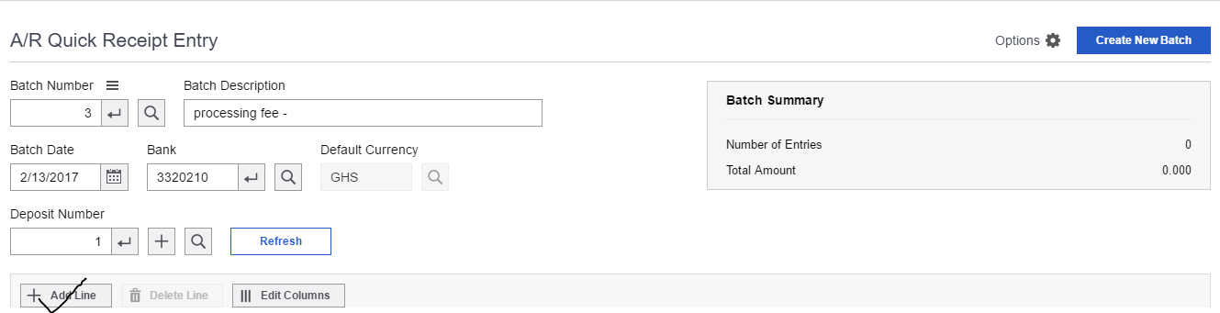

4

4. In the **Receipt Transaction Type** field, specify the transaction type:

Receipt

Prepayment

Unapplied Cash

Miscellaneous Receipt

**Note:** In a new batch, Accounts Receivable displays the default transaction type you selected on the

A/R Options screen.

5. Specify the customer number, receipt type, check number (you can also let Accounts Receivable assign a number), receipt date, amount, payer name, description (of the receipt), fiscal year, and fiscal period.

6. Continue adding the receipts you want to include on the same deposit slip.

7. To print receipts, click **Print Receipt**. For more information, see Printing Receipts.

8. To print the deposit slip, click **Deposit**. For more information, see Printing A/R Deposit Slips Report.

9. Click **Save** when you have finished entering receipts for deposit.



5

After you complete the deposit slip

Print the deposit slip. For more information, see Printing A/R Deposit Slips Report.

### Adding, Editing, or Deleting an Adjustment Batch

You can use the A/R Adjustment Batch List screen to add a new adjustment batch, or delete an open adjustment batch.

You can also use the A/R Adjustment Entry screen to add or delete adjustment batches, and you can use it to edit open batches.

**Note:**To delete a posted batch, or to clear the data for a deleted batch, use the **Clear Deleted And Posted Batches** option on the A/R Clear History screen.

**To create an adjustment batch using the Adjustment Batch List screen:**

1. Open **Accounts Receivable** > **A/R Transactions** > **Adjustment Batch List**.
2. On the Adjustment Batch List, click the **Create New** button to create a new batch.
3. Create and save the batch and entry.

**To create an adjustment batch using the A/R Adjustment Entry screen:**

1. Open **Accounts Receivable** > **A/R Transactions** > **Adjustment Entry**.

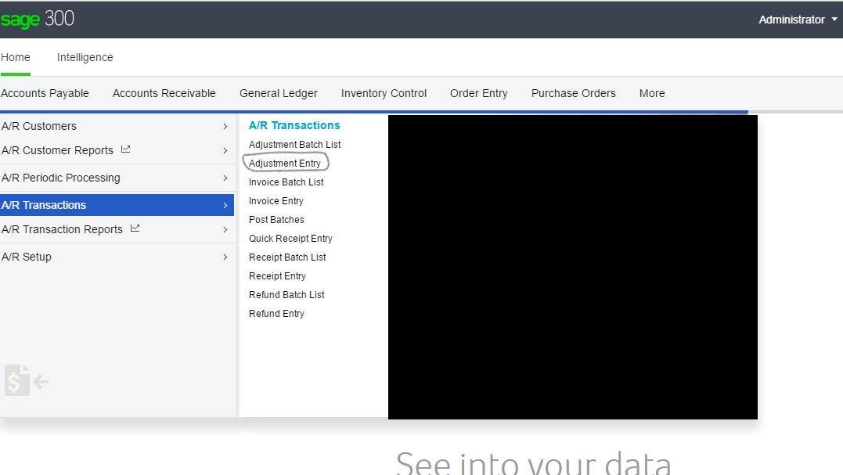

3

2

1

1. Click the **Create New Batch** button.

4

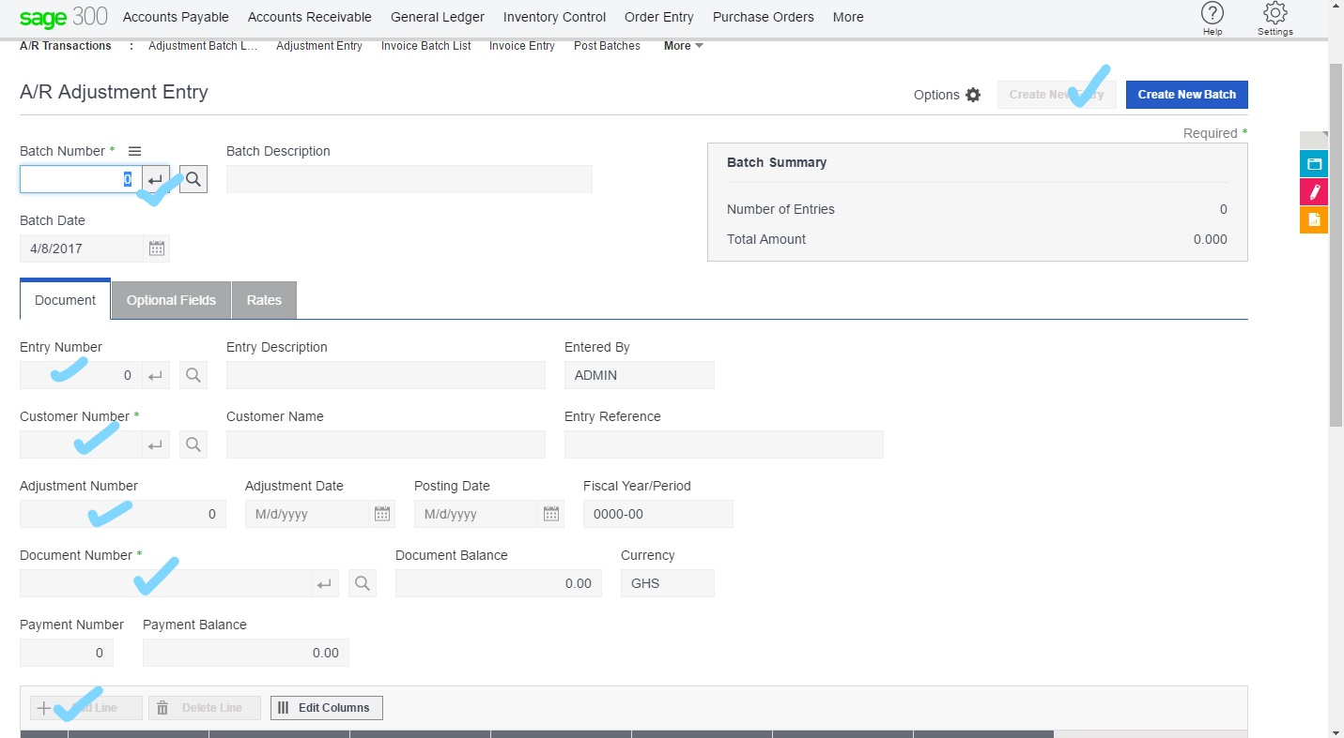

11

10

9

8

6

7

5

1. Create and save the batch and entry.

**To open an existing adjustment batch for editing:**

1. Open **Accounts Receivable** > **A/R Transactions** > **Adjustment Batch List**.
2. Select the batch you want to open, and then click **Open**.

**To delete an open batch:**

1. Open **Accounts Receivable** > **A/R Transactions** > **Adjustment Batch List**.
2. Select the batch.
3. Click **Delete**.

### Printing the A/R Deposit Slips and Day –end Report

The Deposit Slips report lists receipts by deposit number, and groups the receipts by receipt type. In a multicurrency ledger, if a deposit includes multiple currencies, the deposits are also grouped by currency.

You can print this report only if you first selected the **Allow Printing of Deposit Slips** option on the A/R Options screen.

If you select the **Create Deposit Slip When Receipt Batch Is Created** option (on the A/R Options screen),

Accounts Receivable automatically assigns a unique deposit slip number to each receipt batch.

**Tip:** To simplify bank reconciliation at month end, you should prepare a separate deposit slip for each receipt batch, rather than combine receipts from more than one batch on a single deposit slip, or vice versa.

When to Print

Print the report when you finish entering a batch of receipts for deposit and are ready to fill out a bank deposit slip.

Before you start

Make sure **Allow Printing of Deposit Slips** option is selected on the A/R Options screen.

If you use Payment Processing, finish processing credit card payments before you print the deposit slip.

**Warning!** If the **Allow Edit after Deposit Slip Printed** option is not selected on the A/R options screen, the **Charge** and **Quick Charge** buttons are not available after you print the deposit slip, and you cannot process the credit card payments.

If necessary, change the format for the deposit slip you want to print.

**To print the report:**

1. Open **Accounts Receivable** > **A/R Transaction Reports** > **Deposit Slips**.

2. In the **Use Deposit Slip** field, type the name of the format you use for printing deposit slips for the bank.

The default deposit slip form, BKDPST01.RPT, is formatted for laser printers and includes cash and check receipts only.

The form BKDPST02.RPT includes checks, cash, and the other receipt types you use. It also includes a form that helps you fill in an official bank deposit slip.

3. Select additional options, as follows:

**Reprint Previously Printed Deposit Slips.** Select this option if you want to print new copies of deposit slips you printed before.

**Bank Code.** Accept the displayed bank code or specify another one.

Select the bank code that matches the bank code in the batches for which you want to print deposit slips.

If other bank codes are used in the range of batches you specify, Accounts Receivable prints deposit slips only for the batches that use the bank code you enter in this field.

**From Deposit Number/To Deposit Number.** Specify the range of deposits for which you want to print deposit slips, or accept the default values to include all deposit numbers.

1. Click **Print**.

## BANK SERVICES

### Adding Bank Entries

You use the Bank Entry screen to enter and post bank-related transactions, such as bank service charges or mortgage and loan payments.

**Important!** If you add a bank entry by clicking the **Bank Entry** button on the Reconcile Statements screen, you must click the **Calculate** button on the Reconcile Statements screen before saving the reconciliation. If you do not click **Calculate**, an error message appears.

**To add a bank entry:**

1. Do one of the following:

Open **More** > **Bank Services** > **Bank Entry**.

On the Reconcile Statements screen or the Reconcile OFX Statements screen, click **Bank Entry**.

1

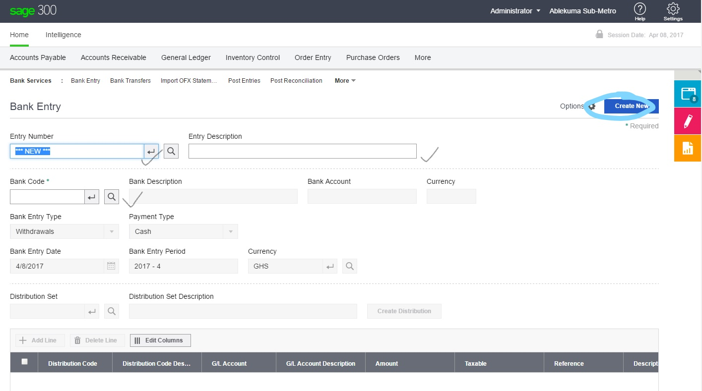

4

3

3

2

2. Enter header information for the bank entry. More...

3. On the table, enter distribution details for the bank entry.

**Note:** If the Bank Options screen specifies a default distribution code, the table automatically displays the first distribution detail. You can accept or edit the detail, or you can delete it by selecting the line, and then clicking **Delete Line**.

Create distribution details using a distribution set

Add details directly on the table

4. Click **Save**

5. Click **Post**.

### Reconciling a Bank Account

You use the Reconcile Statements screen to reconcile bank accounts to bank statements.

**Important!** If you add a bank entry by clicking the **Bank Entry** button on the Reconcile Statements screen, you must click the **Calculate** button on the Reconcile Statements screen before saving the reconciliation. If you do not click **Calculate**, an error message appears.

**Note:** When you change the reconciliation status, the processing date is used as the default reconciliation posting date.

Before you start

1. Post all transactions in the sub-ledgers that affect the bank account for the fiscal period you are reconciling (for example, check batches in Accounts Payable or deposit batches in Accounts

Receivable).

2. Gather your bank statements.

3. If you are reconciling a downloaded (OFX) bank statement:

a. Import the statement into Sage 300. For more information, see Importing OFX Statements.

b. Use the Reconcile OFX Statements screen to match transactions, enter bank transactions, and manually clear or write off any unmatched transactions. For more information, see Reconciling OFX Statements.

c. Use the Reconcile Statements screen to ensure that the bank account is reconciled, as described in this topic.

**To reconcile a bank account:**

1. Open **More** > **Bank Services** > **Reconcile Statements**.

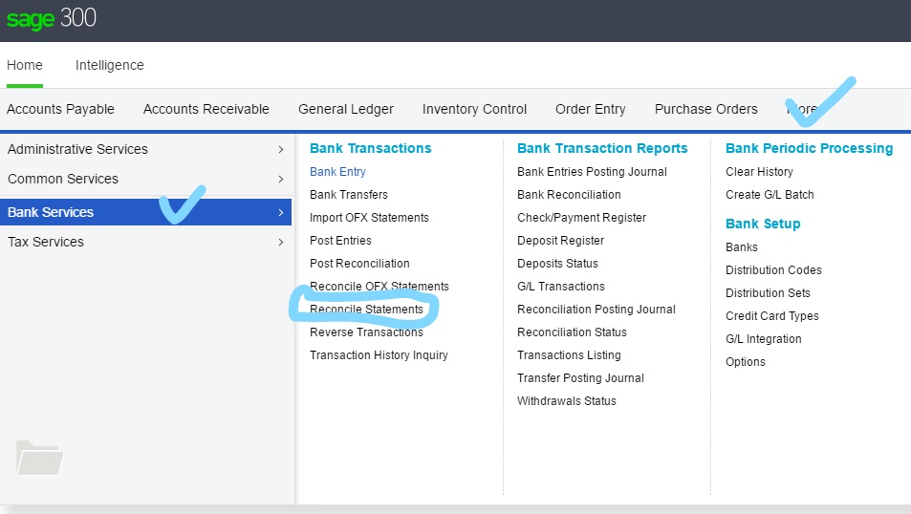

1

3

2

2. In the **Bank Code** field, specify the bank account to reconcile.

3. In the **Reconciliation Description** field, enter a description for the reconciliation.

4. On the Summary tab, enter general information and update amounts. More...

a. In the **Statement Date** field, enter the bank statement date.

b. In the **Statement Balance** field, enter the ending balance from the bank statement.

c. In the **Reconciliation Date** field, specify the date to which to post the reconciliation. You can reconcile outstanding transactions posted up to and including this date.

d. Click **Calculate** to update the amounts displayed on the Summary tab.

**Note:** The **Calculate** button is available if the Adjusted Bank Balance and the Adjusted Book Balance are not equal.

e. Click **Save**.

The **Out of Balance by** field may display a non-zero amount that you need to reconcile. More...

5. On the Summary tab, check that the **Out of Balance by** field displays zero. If it does not:

a. Print the Reconciliation Status report. For more info, (see >Printing the Bank Reconciliation Status

Report.)

b. Compare the report to the bank statement, looking for the reasons for the Out Of Balance amount.

c. Make any necessary corrections, and then click **Calculate**.

When the **Out of Balance by** field displays zero, the adjusted bank balance and the adjusted book balance are equal. This means that the bank account is reconciled, and you can post the bank reconciliation.

7. Compare the bank balance to the G/L account balance, to ensure that they reconcile. (If you use Sage

300 General Ledger, use the Book Balance screen to check the G/L account balance.)

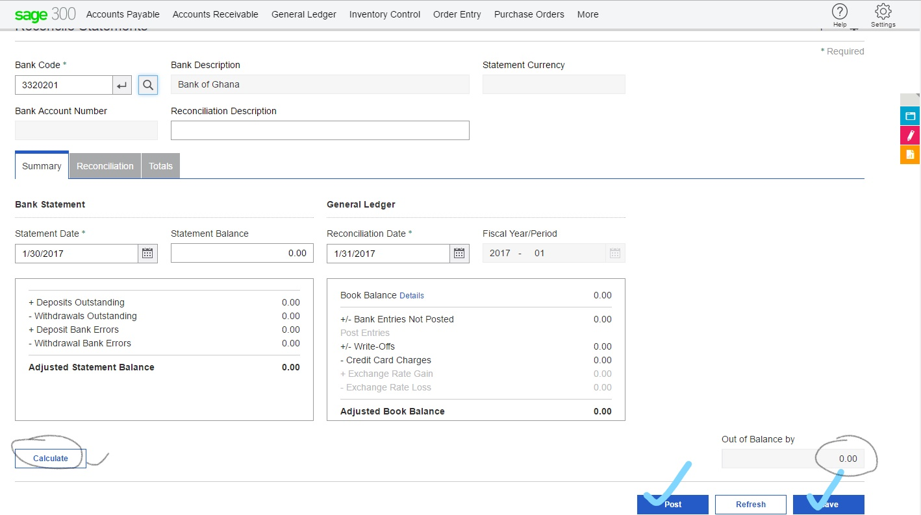

7

4

6

5

8. Click **Save**.

After reconciling a bank account

1. Print the Withdrawals Status and Deposits Status reports. For more information, see Bank

Withdrawals Status Report and Bank Deposits Status Report.

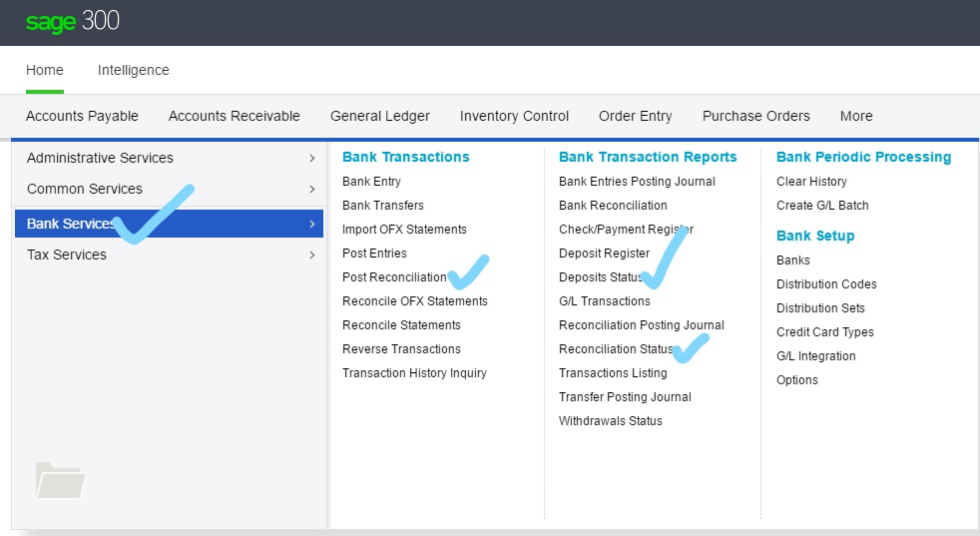

**Note:** These reports are not available after you post the reconciliation.

2. Post the reconciliation. For more information, see Posting Bank Reconciliations.

Print the Reconciliation Posting Journal. For more information, see Bank Reconciliation Posting

Journal Screen.

### Posting Bank Reconciliations

You can post reconciliations using either the Post Reconciliation screen or the Reconcile Statements screen.

Before you start

**To post bank reconciliations from the Post Reconciliation screen:**

1. Open **More** > **Bank Services** > **Post** **Reconciliation**.



1

3

2

2. Select **All Banks** to post all current reconciliations, or select **Range**.

3. If you selected **Range**, use the **From** and **To** fields to specify the range of banks for which to post current reconciliations.

4. Click **Post**.

**To post bank reconciliations from the Reconcile Statements screen:**

1. Open **More** > **Bank Services** > **Post Reconciliation**.

2. Create a reconciliation. For more information, see Reconciling a Bank Account.

3. Click **Post**.

After posting the reconciliation

### Printing the Bank Reconciliation Status Report

**To print the Reconciliation Status report:**

1. Open **More** > **Bank Transaction Reports** > **Reconciliation Status**. Open **More** > **Bank>Services** >**Reconciliation Status**.

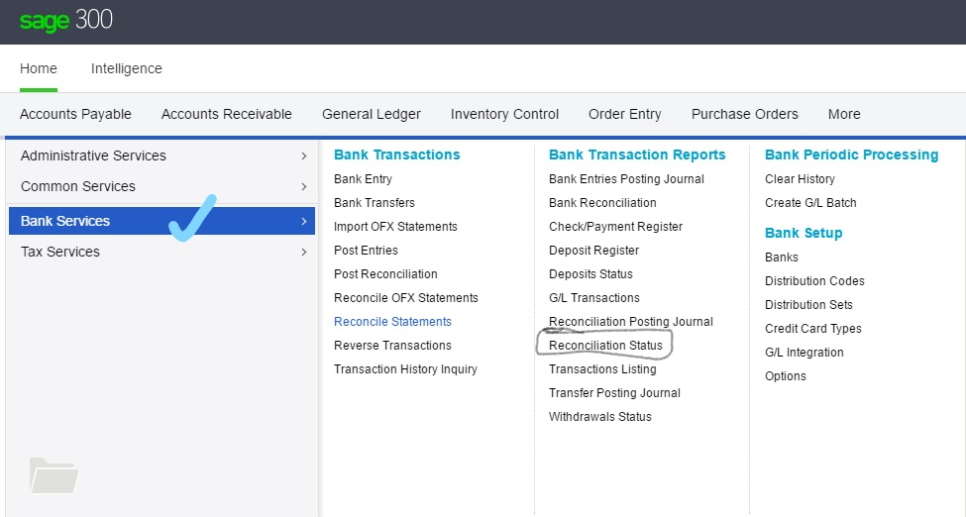

3

2

1

2. Specify the bank or range of banks to include on the report.

3. Specify criteria for selecting transactions to include on the report, including:

The range of dates to which transactions were posted.

The source application (or range of applications) that sent the transactions to Bank Services.

Reconciliation statuses for withdrawals. For more information, see Withdrawal Reconciliation

Statuses.

Reconciliation statuses for deposits. For more information, see Deposit Reconciliation Statuses.

**Note:** The report includes only withdrawals and deposits with the reconciliation statuses you select.

.

4. Select the **Print Deposit Details** option to include details of individual receipts in a deposit.

5. Click **Print**.

## GENERAL LEDGER

### Adding a Journal Entry

A journal entry in General Ledger is like a manual journal entry. The sum of the debits equals the sum of the credits.

Each debit line and each credit line in a journal entry is called a detail. You use the G/L Journal Entry screen to maintain batches, journal entries, and journal entry details.

**To add a journal entry:**

1. Open **General Ledger** > **G/L Transactions** > **Journal Entry**.

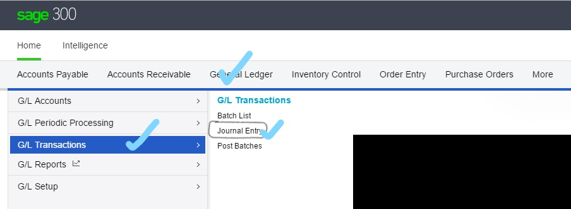

3

2

1

2. Click the **Create New Batch** button in the top right section of the screen.

General Ledger provides the next batch number, and moves to the Batch Description field.

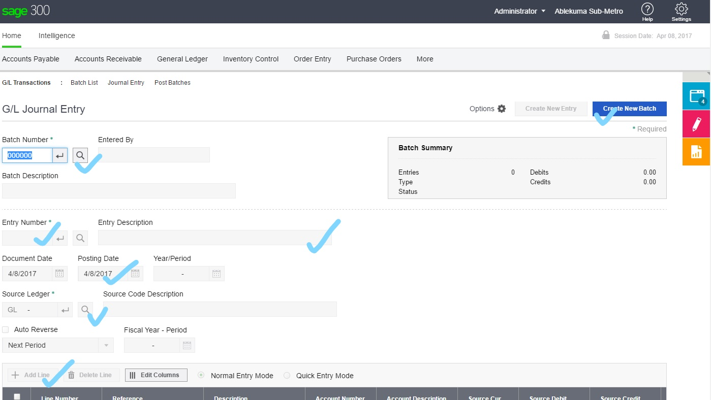

8

5

4

7

6

3. Enter a description for the batch.

4. Enter header information for the entry, as follows:

a. In the top right section of the screen, click the **Create New Entry** button.

General Ledger inserts the next entry number.

b. Enter a description for the entry.

c. In the **Document Date** and **Posting Date** fields, specify dates for the journal entry.

d. Use the **Year/Period** field to specify the fiscal year and period to which to post the transaction.

(The default fiscal year and period is determined by the date you entered in the Date field.)

e. Use the **Source Code** field to specify the source code for the transaction.

General Ledger displays the default source code from the Posting tab of the Options screen, but you can change the code.

f. Select **Normal** or **Quick** as the entry mode.

This option controls the number of fields visited when you are adding new transaction details.

Note

g. If the transaction should be reversed in the next fiscal period (for example, if the entry is an accrual), select the **Auto Reverse** option.

5. Enter debit and credit information in the detail table.

**(Check the Debit and Credit totals and Make sure out of balance is zero. If not Click on update)**

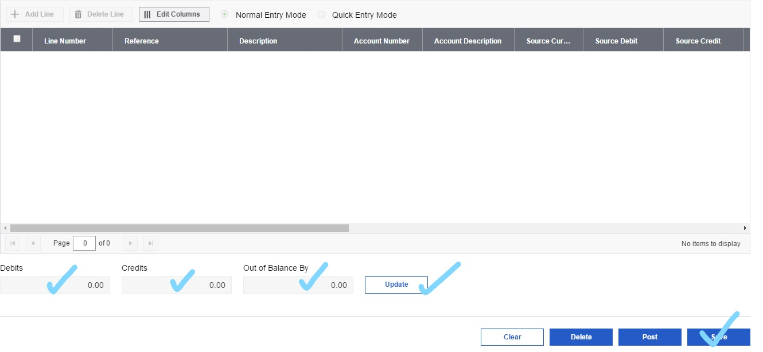

9

11

10

**Note:** If you have a multicurrency ledger and you are entering details for a multicurrency account, you can select the source currency, the rate type, and the rate for each detail. Each detail can use a different source currency, and you can override the displayed exchange rates as required.

6. To view or edit optional fields for a selected detail, click the **Optional Fields** section of the detail column and click the Finder button to select from the available options

The Journal Entry Optional Fields screen appears.

You can add or delete optional fields for the detail. However, you can add only optional transaction fields that are defined for the account.

**Note:**

You can also change the value for the optional field, as follows:

If the optional field is validated, you must specify a value that is defined for the optional field. If the optional field allows a blank, you can also leave the value blank.

If the optional field is not validated, you can select a defined value, or you can enter any value, providing your entry does not exceed the length specified for the optional field.

7. Click **Save**.

### Posting Transaction Batches (After adding journal entries)

The process of transferring information from a batch of transactions to the general ledger accounts is called posting. General Ledger lets you post transactions directly to accounts, or post them provisionally to test their effect.

You can post batches from the following screens:

**Post Batches.** Post a single batch, a range of batches, or all unposted batches.

**Batch List.** Post a single batch or all unposted batches.

**Note:** On the G/L Batch List screen, you cannot provisionally post all batches, though you can provisionally post individual batches.

**Journal Entry.** Post a single batch.

**Note:** On the G/L Journal Entry screen, you cannot provisionally post batches.

Before you start

**To post transaction batches from the G/L Post Batches screen:**

1. Open **General Ledger** > **G/L Transactions** > **Post Batches**.

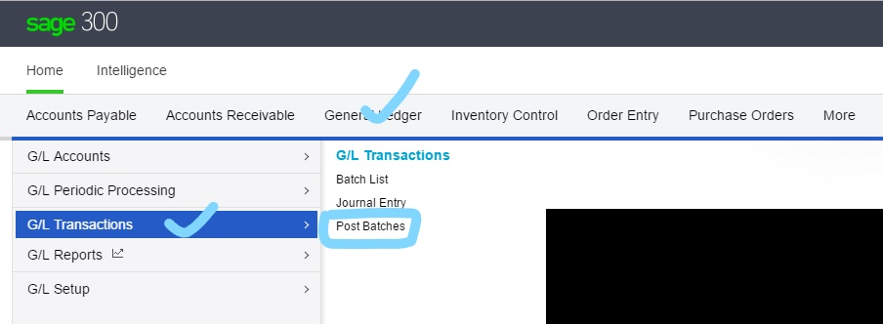

3

2

1

2. Specify the batches to post by selecting **All Batches** or **Range**.

If you want to post a single batch, enter the same batch number for the beginning and end of the range.

3. Click **Post** to post batches permanently.

Click **Provisional Post** to post on a temporary basis.

**To post transaction batches from the G/L Batch List screen:**

1. Open **General Ledger** > **G/L Transactions** > **Invoice Batches**

2. If you are posting a single batch, select the batch.

3. Click one of the following buttons:

**Post.** Post the selected batch.

**Provisional Post.** Provisionally post the selected batch.

**Post All.** Post all unposted batches.

**To post transaction batches from the G/L Journal Entry screen:**

1. Open **General Ledger** > **G/L Transactions** > **Post Batches**.

2. Select a batch.

3. Click **Post** to post the batch that is currently displayed.

After posting batches

If errors were found and placed in a new batch during posting, correct the errors, then post the batch.

Print the Posting Journal for an audit trail report of posted transactions.

To report provisional transactions, print the Provisional Posting Journal.

When ready, post provisional batches permanently.